**Code Smells - Pedro Arruda 60663**

Location:

\ganttproject\src\main\java\net\sourceforge\ganttproject\PreferenceServiceImpl.java

This class is **dead code** due to it not being used and therefore should be removed to reduce code size and bring simpler support.

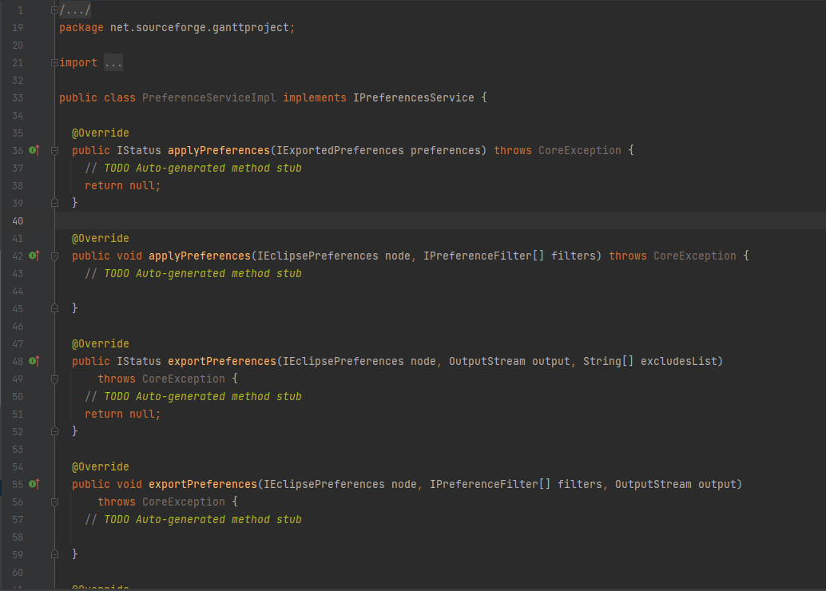

Location:

\ganttproject\src\main\java\net\sourceforge\ganttproject\TreeTableCellEditorImpl.java

This entire class has **no comments** making it very difficult for anyone to understand what the methods/class are doing or should be doing.

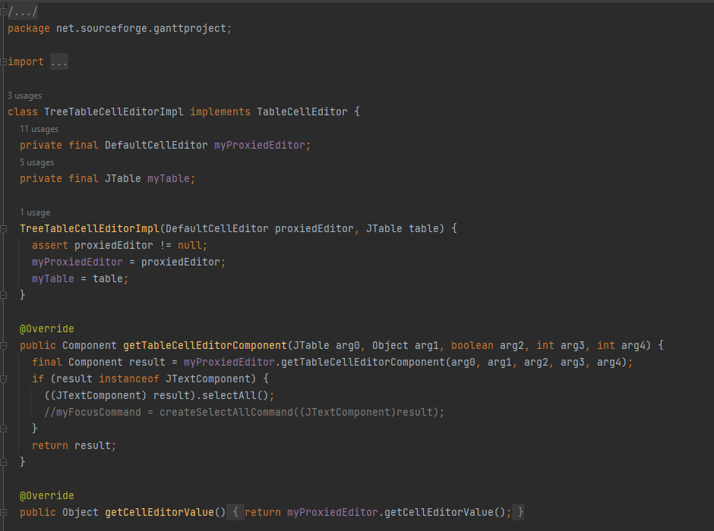

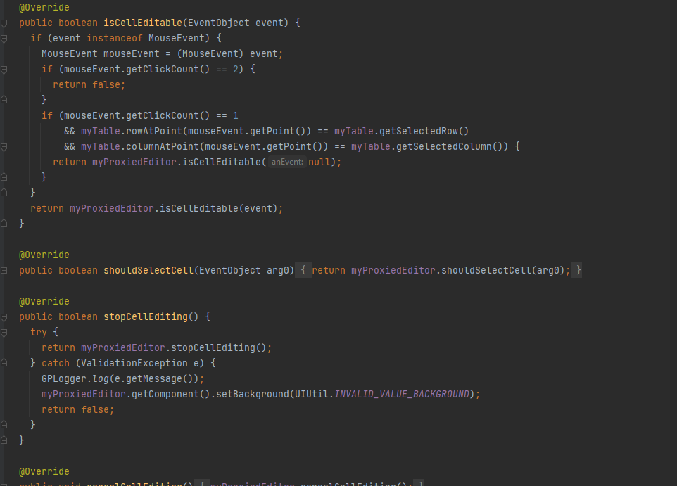

Location:

\ganttproject\src\main\java\net\sourceforge\ganttproject\TreeTableCellEditorImpl.java

Same class as before, this class has a **really large size** (1270 lines), turning it into a **god class** due to the amount of responsability it has and making it even more difficult and exhausting to understand.

This class should, for example, be divided into different classes, each with its specific functionalities.

